Customer Support Chatbot in Hindi Language

Abhay Singh Chauhan (Author)
Student, Computer Science and Engineering
Medi-Caps University
Indore, India
e-mail: abhaysc.01@gmail.com
Parth Gupta (Author)
Student, Computer Science and Engineering
Medi-Caps University
Indore, India
e-mail: parthgupta9999@gmail.com

Abstract— As the number of services are increasing each passing day, the number of queries related to a particular service is also increasing rapidly. To provide solutions to these queries the companies are hiring a huge number of employees that can work as customer support. But this process of providing solution to the customers query is very slow for customer and expensive for company. To curb this problem there should be a solution feasible and accessible to everyone. The objective of our project is to provide solution to such problem. The proposed idea is to create a customer support chatbot that responds to the request made by the customer. The chatbot should be capable enough to interpret to all queries of the customers, analyse them and understand the intent of the queries. There are many different chatbots already present in the real time use but this one-use Hindi Language and voice communication. The proposed idea can be summarized as a customer supports chatbot that performs to accept customers query and to give appropriate solution in Hindi language over voice communication.

Introduction
Chat bots or Virtual Assistants have been designed to simplify the interaction between computers and humans and have hit the market. A chat bot is a software that uses artificial intelligence (AI) that can converse (or chat) with a user in natural language via virtual chat rooms, websites, mobile apps and messaging applications or through the telephone. Chatbots are often referred to as one of the most promising and advanced form of interaction between machines and humans. Although, from a technological perspective, a chatbot can only represent the evolution of a Question Answering system based on Natural Language Processing (NLP). Generating responses to user queries in human like natural language is one of the most common examples of Natural Language Processing leveraging in various enterprises’ end-use applications. Chatbot applications slick interactions between services and people, improving customer experience. Simultaneously, chatbots offer companies various opportunities to enhance the customers loyalty and ensure operational efficiency by minimizing the surplus cost of customer service. Chatbot solutions have to effectively perform both of the tasks for successful execution. Human support plays a vital role here: Irrespective of the kind of approach and the platform, human intervention plays a crucial role in training, optimizing and configuring the chatbot system. There are two different tasks which form the basis of a chatbot are User Request Analysis and Returning the response.

Selecting a Template (Heading 2)
This is the primary task that a chatbot performs. In this task, it analyses the users request and identifies the user intent in order to extract relevant entities.

This ability of identifying the user’s intent and extracting data and relevant entities present in the user’s request is the first and basic condition and the most crucial step at the core of a chatbot: If you fail to correctly acknowledge the user’s request, you will fail to provide the correct answer.

Returning the Response
First the user’s intent is identified and once that is done, the chatbot can provide the most appropriate response for the user’s query.

The answer can be:

- A predefined and generic text.

- A text retrieved from a knowledge database containing different answers.

- A contextualized piece of information that is user
data oriented. Data which is stored in enterprise systems.

- The result of an action that the chatbot has performed by interacting with backend applications.

A render question helps the chatbot to correctly understand the user’s request. Chatbot can be developed by the use of different approaches and tools. Depending on the application you want to address, some specific chat bot technologies are more suitable than others. In order to achieve the desired responses, the fusion of different AI forms such as machine learning, semantic understanding, and natural language processing may be the best option.

LITERATURE REVIEW
Customer satisfaction with a company’s services is often seen as the key to success and long-term competitiveness for a company. The industry such as Product Delivery, is getting a lot of attention as customer satisfaction. The technology platforms allow modelling the entire Product Delivery ecosystem with Artificial Intelligent (AI) to simulate scenarios of different economic, market and individual conditions. There is an increase in the demand for AI capabilities to interact with customers in benefits, insurance coverages and claims processes. Because it removes human factors and provides 24-hours service. In order to truly be effective and make business processes automated an alternate system is required. An advance dialogue system known as AI chatbot application system could automate the entire business processes. Thus, chatbot application system must have Natural Language Understanding (NLU) and Natural Language Processing (NLP) so that it can understand what customers are looking for. In the case of the Mutual funds insurance industry, chatbot can be used to answer basic questions, resolve insurance claims, sell products and make sure customers are properly covered by their insurance. AI chatbot can analyze data better than humans to more accurately predict each customer’s risk, thereby providing customers with the right amount of insurance and companies with protection from risky customers.

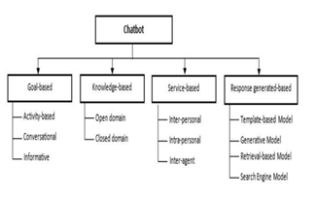
- Taxonomy of Chatbot Application.

PROBLEM STATEMENT AND OBJECTIVE

This project will consist of creating two important inter-dependent modules. They can be described as follows:
      - Chatbot (based on NLP)
      - Server (Deep Learning model)
The Chatbot will be comprise of:
            - The chatbot will be build using NLP
            - It will have ability to communicate using voice.
            - To learn and understand Hindi Language through NLP
The Server having operations as:
- Pre-processing of the queries given by customer.
- Process that in ML, NLP engine to give the perfect solution to the customer.
- To learn and understand through ML, NLP engine.

SCOPE & OVERVIEW

Justification:

In India, Around Lacs of queries are asked on daily basis in sectors like Telecommunication, Financial services, Banking, etc. For this, these sectors hire a huge number of employees to work as customer support and this increases the expenses of the companies. Most of the queries are common and repeated, keeping this in mind a use of chatbot will be very helpful for the companies to resolve similar queries and also this will help to save money. Also, there are multiple advantages of using chatbot as a support compared to Manual support systems like:
- 24/7 available.

- Instant communication.

- Reduced cost.

- Tailored solutions.

Product scope description:
- The product should be able to classify query type and provide appropriate solutions.
- If new queries are raised the product should redirect to support admin and Train itself for the query for future use.

Acceptance Criteria:
- The product should be able to identify that the query is related to its domain or not.
- All modules used to develop the bot should work synchronously.
- The interactions between the user and the product should be fast.

Deliverables:
- Segregation between queries related to product delivery domain and other domains
- Identify the most asked query and train itself to provide much tailored solutions for the same query.
- Should redirect the user to support admin if bot is not able to provide solution of a query related to product delivery domain.

Assumptions:
- Server has NVIDIA GPU support
- TensorFlow GPU drivers are up to date
- Chatbot have been trained beforehand
- The Queries should be pre-defined.

PROPOSED SYSTEM

Analysis/Framework/Algorithm

TensorFlow: It is the fastest and simplest way to do image recognition on your laptop or computer without any GPU because it is just an API and your CPU is good enough for this. TensorFlow provides the opportunity to adapt a pre-trained model to new classes of data with several advantages.

Flask: is a micro web framework written in Python. It is classified as a microframework because it does not require particular tools or libraries. It has no database abstraction layer, form validation, or any other components where pre-existing third-party libraries provide common functions.

HTML, CSS and JavaScript: Useful for front end development and building user interfaces or UI components.

NLP (Natural Language processing): Natural language processing is a subfield of linguistics, computer science, and artificial intelligence concerned with the interactions between computers and human language, in particular how to program computers to process and analyse large amounts of natural language data

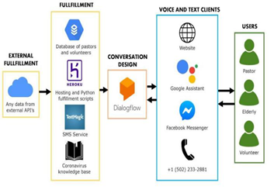
- Framework for Chatbot.

PROPOSED SYSTEM

Step 1: Accepting Users Query.
The Chatbot will accept any user’s Query.

Step 2: Analysing the Query.
The Chatbot will analyse the user’s asked query and check for the most appropriate solution for it in the Database.

Step 3: Reply to Query.
The Chatbot will provide solution to the user’s query after being trained on the given data.

Use Case Diagram
A use case diagram at its simplest is a representation of a user's interaction with the system that shows the relationship between the user and the different use cases in which the user is involved.

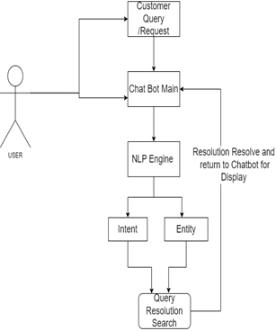
- Use Case Diagram.

Table -1: Requirements Table

 | Details of Hardware and Software
 | Operating System | Windows 7/8/8.1/10, Linux
 |  | VS Code, TensorFlow, Flask, HTML, CSS and JavaScript
 | Tools and Framework
 | Language Requirement | Python, JavaScript
 | Server | Locally hosted
 |  | Server

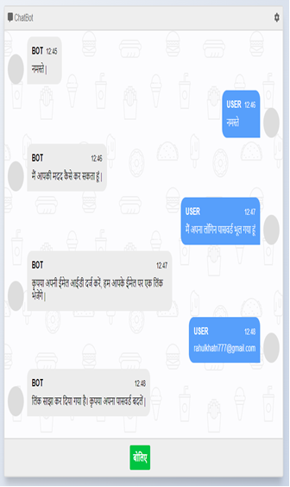
- Demo User Interface.

CONCLUSIONS

In this semester we have created prototype of project along with software and framework analysis report to build customer support chatbot. The query can be further processed to detect query type inserted by user and provide optimal solution for it. The chatbot will contain most of the queries related to product delivery and try to provide solution for the user’s query as fast as it can. The chatbot will use new queries that is not known by the chatbot to train itself with the help of NLP.

REFERENCES

[1] Dialogflow Documentation | Google Cloud https://cloud.google.com/dialogflow/docs

[2] R Khan, A Das - A complete guide to getting started with chatbots, 2018 – Springer

[3] Evaluating and informing the design of chatbots

M Jain, P Kumar, R Kota, SN Patel - Proceedings of the

2018 Designing …, 2018 - dl.acm.org

[4] Chatbots for learning: A review of educational chatbots for the Facebook Messenger

P Smutny, P Schreiberova - Computers & Education, 2020-Elsevierhttps://www.youtube.com/watch?v=38sL6pAD Cog

[5] Chatbots and conversational interfaces: Three domains of use

S Di Gaetano, P Diliberto - Fifth International Workshop on Cultures of …, 2018 - ceur-ws.org

[6] A Psychologist Chatbot Developing Experience - CEUR-WS.org

[7] Methodology for the Implementation of Virtual Assistants for Education Using Google Dialogflow https://www.researchgate.net/publication/336827160 _Methodology_for_the_Implementation_of_Virtual_Assist ants_for_Education_Using_Google_Dialogflow

The equations are an exception to the prescribed specifications of this template. You will need to determine whether or not your equation should be typed using either the Times New Roman or the Symbol font (please no other font). To create multileveled equations, it may be necessary to treat the equation as a graphic and insert it into the text after your paper is styled.
Number equations consecutively. Equation numbers, within parentheses, are to position flush right, as in (1), using a right tab stop. To make your equations more compact, you may use the solidus ( / ), the exp function, or appropriate exponents. Italicize Roman symbols for quantities and variables, but not Greek symbols. Use a long dash rather than a hyphen for a minus sign. Punctuate equations with commas or periods when they are part of a sentence, as in
       
Note that the equation is centered using a center tab stop. Be sure that the symbols in your equation have been defined before or immediately following the equation. Use “(1)”, not “Eq. (1)” or “equation (1)”, except at the beginning of a sentence: “Equation (1) is . . .”

Some Common Mistakes
- The word “data” is plural, not singular.
- The subscript for the permeability of vacuum μ₀, and other common scientific constants, is zero with subscript formatting, not a lowercase letter “o”.
- In American English, commas, semi-/colons, periods, question and exclamation marks are located within quotation marks only when a complete thought or name is cited, such as a title or full quotation. When quotation marks are used, instead of a bold or italic typeface, to highlight a word or phrase, punctuation should appear outside of the quotation marks. A parenthetical phrase or statement at the end of a sentence is punctuated outside of the closing parenthesis (like this). (A parenthetical sentence is punctuated within the parentheses.)
- A graph within a graph is an “inset”, not an “insert”. The word alternatively is preferred to the word “alternately” (unless you really mean something that alternates).
- Do not use the word “essentially” to mean “approximately” or “effectively”.
- In your paper title, if the words “that uses” can accurately replace the word “using”, capitalize the “u”; if not, keep using lower-cased.
- Be aware of the different meanings of the homophones “affect” and “effect”, “complement” and “compliment”, “discreet” and “discrete”, “principal” and “principle”.
- Do not confuse “imply” and “infer”.
- The prefix “non” is not a word; it should be joined to the word it modifies, usually without a hyphen.
- There is no period after the “et” in the Latin abbreviation “et al.”.
- The abbreviation “i.e.” means “that is”, and the abbreviation “e.g.” means “for example”.
An excellent style manual for science writers is [7].

Using the Template
After the text edit has been completed, the paper is ready for the template. Duplicate the template file by using the Save As command, and use the naming convention prescribed by your conference for the name of your paper. In this newly created file, highlight all of the contents and import your prepared text file. You are now ready to style your paper.

Authors and Affiliations
The template is designed so that author affiliations are not repeated each time for multiple authors of the same affiliation. Please keep your affiliations as succinct as possible (for example, do not differentiate among departments of the same organization). This template was designed for two affiliations.

For author/s of only one affiliation (Heading 3): To change the default, adjust the template as follows.

Selection (Heading 4): Highlight all author and affiliation lines.

Change number of columns: Select Format >
Columns >Presets > One Column.

Deletion: Delete the author and affiliation lines for the second affiliation.

For author/s of more than two affiliations: To change the default, adjust the template as follows.

Selection: Highlight all author and affiliation lines.

Change number of columns: Select Format >
Columns > Presets > One Column.

Highlight author and affiliation lines of affiliation 1 and copy this selection.

Formatting: Insert one hard return immediately after the last character of the last affiliation line. Then paste the copy of affiliation 1. Repeat as necessary for each additional affiliation.

Reassign number of columns: Place your cursor to the right of the last character of the last affiliation line of an even numbered affiliation (e.g., if there are five affiliations, place your cursor at end of fourth affiliation). Drag the cursor up to highlight all of the above author and affiliation lines. Go to Format > Columns and select “2 Columns”. If you have an odd number of affiliations, the final affiliation will be centered on the page; all previous will be in two columns.

Identify the Headings
Headings, or heads, are organizational devices that guide the reader through your paper. There are two types: component heads and text heads.
Component heads identify the different components of your paper and are not topically subordinate to each other. Examples include Acknowledgments and References and, for these, the correct style to use is “Heading 5”. Use “figure caption” for your Figure captions, and “table head” for your table title. Run-in heads, such as “Abstract”, will require you to apply a style (in this case, italic) in addition to the style provided by the drop down menu to differentiate the head from the text.
Text heads organize the topics on a relational, hierarchical basis. For example, the paper title is the primary text head because all subsequent material relates and elaborates on this one topic. If there are two or more sub-topics, the next level head (uppercase Roman numerals) should be used and, conversely, if there are not at least two sub-topics, then no subheads should be introduced. Styles named “Heading 1”, “Heading 2”, “Heading 3”, and “Heading 4” are prescribed.

Figures and Tables

Positioning Figures and Tables: Place figures and tables at the top and bottom of columns. Avoid placing them in the middle of columns. Large figures and tables may span across both columns. Figure captions should be below the figures; table heads should appear above the tables. Insert figures and tables after they are cited in the text. Use the abbreviation “Fig. 1”, even at the beginning of a sentence.
- Table Type Styles
Table Head | Table Column Head
Table Head | Table column subhead | Subhead | Subhead
copy | More table copyª
a. Sample of a Table footnote. (Table footnote)
We suggest that you use a text box to insert a graphic (ideally 300 dpi), with all fonts embedded) because, in an MSW document, this method is somewhat more stable than directly inserting a picture.
To have non-visible rules on your frame, use the MSWord pull-down menu, select Format > Borders and Shading > Select “None”.
- Example of a ONE-COLUMN figure caption.
Please see last page of this document for AN EXAMPLE of a 2-COLUMN Figure.
Figure Labels: Use 8 point Times New Roman for Figure labels. Use words rather than symbols or abbreviations when writing Figure axis labels to avoid confusing the reader. As an example, write the quantity “Magnetization”, or “Magnetization, M”, not just “M”. If including units in the label, present them within parentheses. Do not label axes only with units. In the example, write “Magnetization (A/m)” or “Magnetization {A[m(1)]}”, not just “A/m”. Do not label axes with a ratio of quantities and units. For example, write “Temperature (K)”, not “Temperature/K”.

Footnotes
Use footnotes sparingly (or not at all) and place them at the bottom of the column on the page on which they are referenced. Use Times 8-point type, single-spaced. To help your readers, avoid using footnotes altogether and include necessary peripheral observations in the text (within parentheses, if you prefer, as in this sentence).

Copyright Forms and Reprint Orders
You must submit the IEEE Electronic Copyright Form (ECF) per Step 7 of the CPS author kit’s web page. THIS FORM MUST BE SUBMITTED IN ORDER TO PUBLISH YOUR PAPER.
Please see Step 9 for ordering reprints of your paper. Reprints may be ordered using the form provided as <reprint.doc> or <reprint.pdf>.

Acknowledgment
The preferred spelling of the word “acknowledgment” in America is without an “e” after the “g”. Avoid the stilted expression, “One of us (R.B.G.) thanks . . .” Instead, try
“R.B.G. thanks”. Put applicable sponsor acknowledgments here; DO NOT place them on the first page of your paper or as a footnote.

References
List and number all bibliographical references in 9-point Times, single-spaced, at the end of your paper. When referenced in the text, enclose the citation number in square brackets, for example [1]. Where appropriate, include the name(s) of editors of referenced books. The template will number citations consecutively within brackets [1]. The sentence punctuation follows the bracket [2]. Refer simply to the reference number, as in [3]—do not use “Ref. [3]” or “reference [3]” except at the beginning of a sentence: “Reference [3] was the first . . .”
Number footnotes separately in superscripts. Place the actual footnote at the bottom of the column in which it was cited. Do not put footnotes in the reference list. Use letters for table footnotes.
Unless there are six authors or more give all authors’ names; do not use “et al.”. Papers that have not been published, even if they have been submitted for publication, should be cited as “unpublished” [4]. Papers that have been accepted for publication should be cited as “in press” [5]. Capitalize only the first word in a paper title, except for proper nouns and element symbols.
For papers published in translation journals, please give the English citation first, followed by the original foreign-language citation [6].

- G. Eason, B. Noble, and I. N. Sneddon, “On certain integrals of Lipschitz-Hankel type involving products of Bessel functions,” Phil. Trans. Roy. Soc. London, vol. A247, pp. 529–551, April 1955. (references)
- J. Clerk Maxwell, A Treatise on Electricity and Magnetism, 3rd ed., vol. 2. Oxford: Clarendon, 1892, pp.68–73.
- I. S. Jacobs and C. P. Bean, “Fine particles, thin films and exchange anisotropy,” in Magnetism, vol. III, G. T. Rado and H. Suhl, Eds. New York: Academic, 1963, pp. 271–350.
- K. Elissa, “Title of paper if known,” unpublished.
- R. Nicole, “Title of paper with only first word capitalized,” J. Name Stand. Abbrev., in press.
- Y. Yorozu, M. Hirano, K. Oka, and Y. Tagawa, “Electron spectroscopy studies on magneto-optical media and plastic substrate interface,” IEEE Transl. J. Magn. Japan, vol. 2, pp. 740–741, August 1987 [Digests 9th Annual Conf. Magnetics Japan, p. 301, 1982].
- M. Young, The Technical Writer’s Handbook. Mill Valley, CA: University Science, 1989.
- Electronic Publication: Digital Object Identifiers (DOIs):
Article in a journal:
- D. Kornack and P. Rakic, “Cell Proliferation without Neurogenesis in Adult Primate Neocortex,” Science, vol. 294, Dec. 2001, pp. 2127-2130, doi:10.1126/science.1065467.
Article in a conference proceedings:
- H. Goto, Y. Hasegawa, and M. Tanaka, “Efficient Scheduling Focusing on the Duality of MPL Representatives,” Proc. IEEE Symp. Computational Intelligence in Scheduling (SCIS 07), IEEE Press, Dec. 2007, pp. 57-64, doi:10.1109/SCIS.2007.357670.

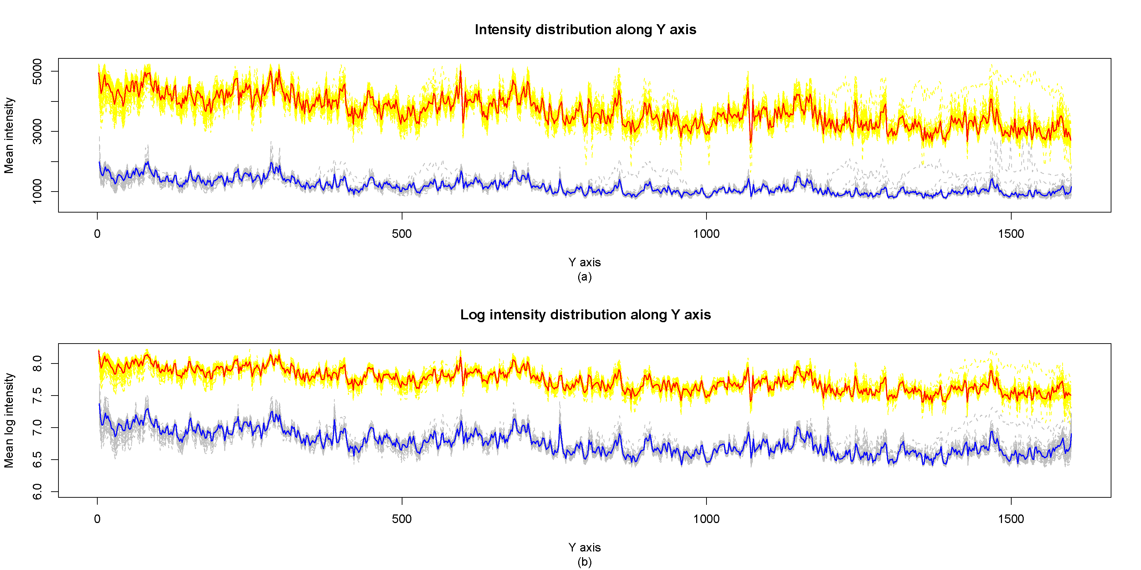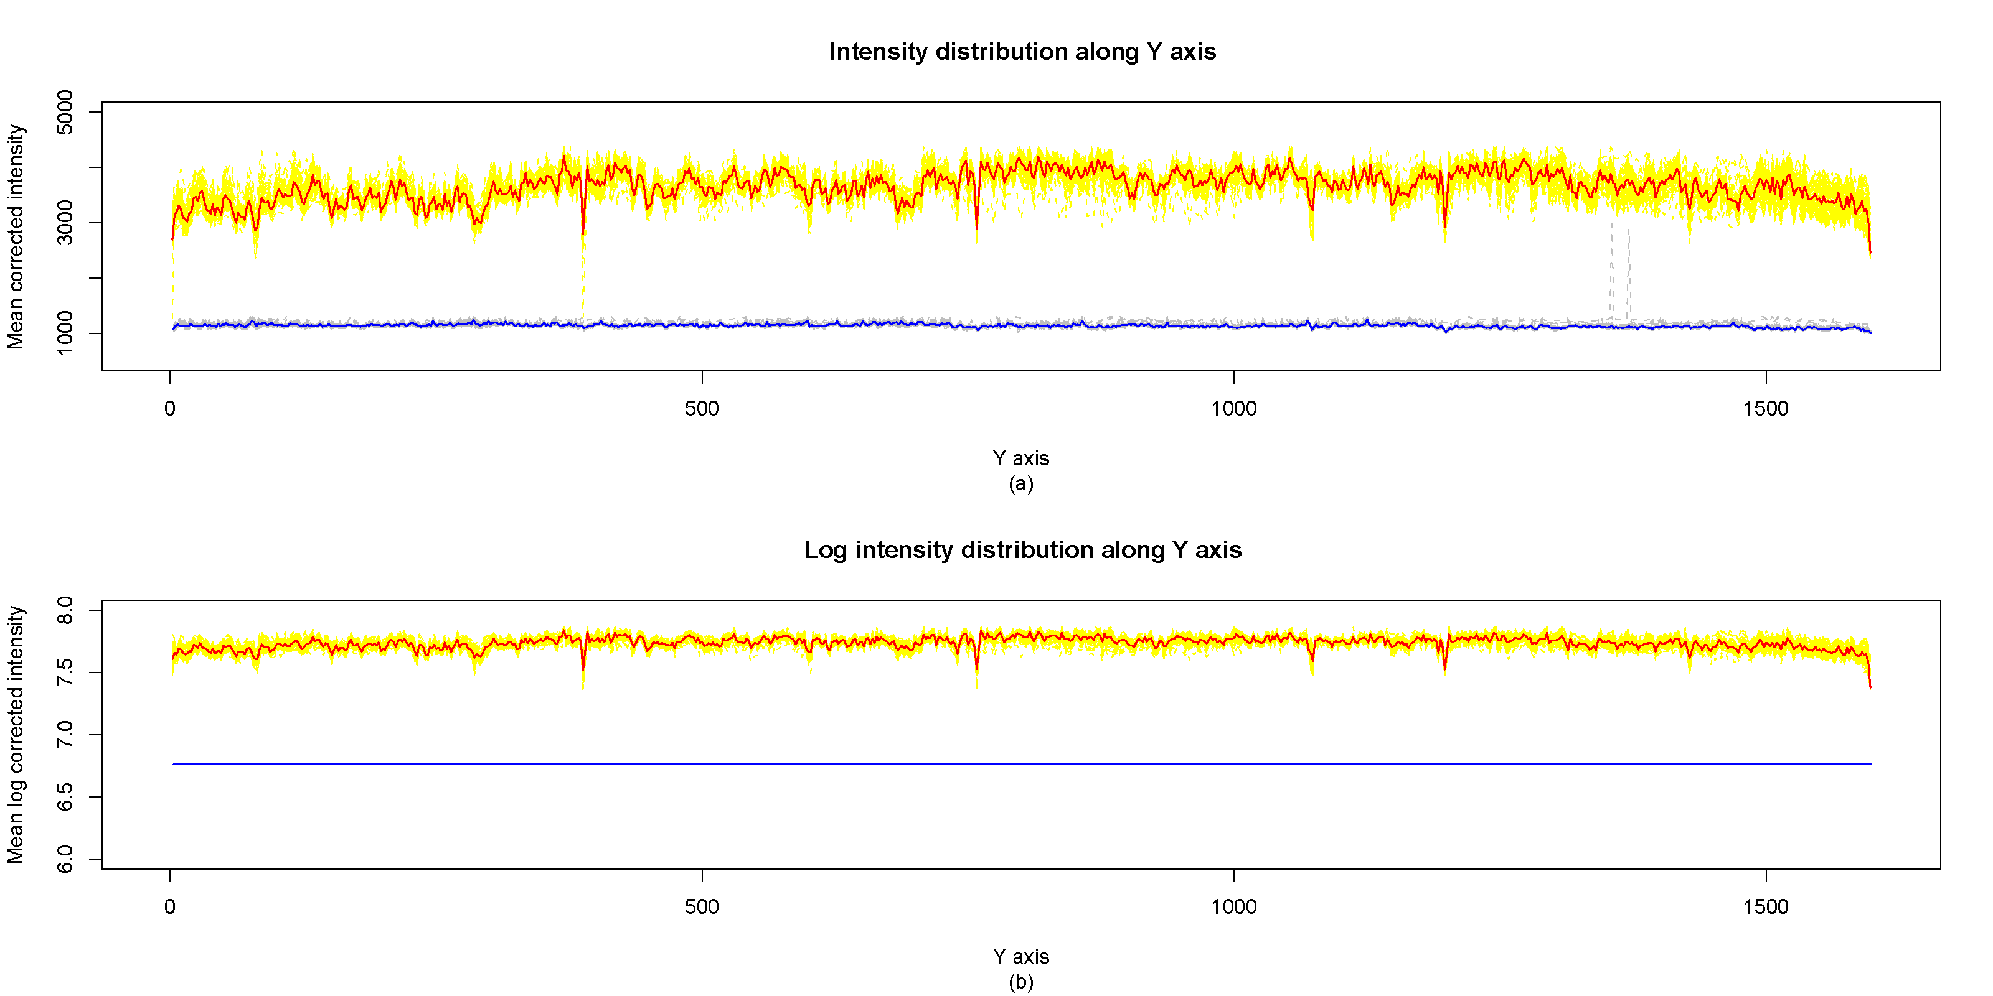
- Example of a TWO-COLUMN figure caption: (a) this is the format for referencing parts of a figure.

